Additional Services
- Prescription Discount Program exclusively for La Esperanza Clinic patients
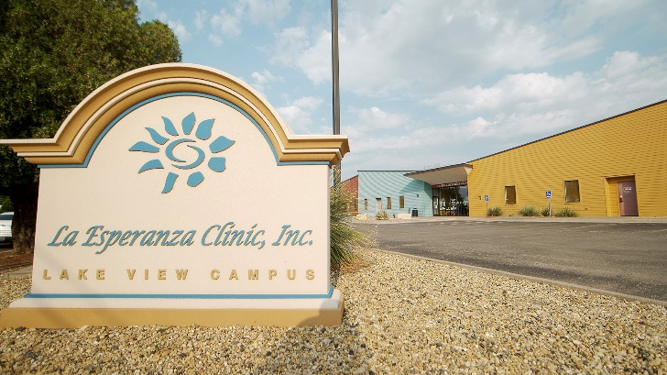

The Mission of La Esperanza Clinic is to provide quality primary and preventative health and dental care services to all people, particularly the medically underserved of San Angelo and the Concho Valley.
- On-site enrollment:

-Affordable Care Act
-Texas Healthy Women
-Medicaid
-Medicare
-SNAP
Call for an appointment
(325) 949-6220.

- Success By 6 resources for teen parents: (325) 949-7974.

- Telehealth Available
- After hours nurse line:
(325) 658-5339

- Patient Portal – 24/7 on-line access to medical records

- Mobile Registration and Check-In
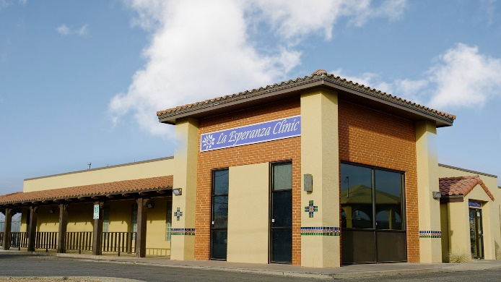

To schedule an appointment call
(325) 658-5339
Se Habla Español
www.EsperanzaHealth.org
Twitter: @LaEsperanzaCli1

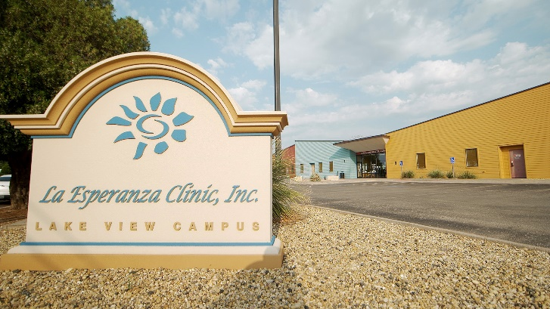
Affordable Ways to Pay
- Sliding Fee Scale Discount Program
- Medicare/Medicaid
- Private Insurance
- VISA/Master Card, Cash & Check
- On-site assistance with applying for state
services such as, Medicaid and CHIP.

*Proof of Income is required from all members in the patient’s household in order for patient to be eligible for Sliding Fee Scale Discount Program.

Proof of Earned Income:
If patient gets paid bring most recent pay stubs
- One month of most recent pay stubs
- If no pay stubs, provide Employment Verification Form
For all patients, a filed tax return will be accepted until June 30 of the current year.

Proof of Unearned Income:
- Current year Social Security Award Letter for Supplemental Income
- Unemployment Benefits for current year Disability Award Letter
- Pell Grants
- Child Support (current printout from Attorney General’s office)
- Retirement check for current year or statement showing payments

No Income:
- Bring a Letter of Support (w/ the $ amount provided in a month) and a copy of the picture ID of the supporter if they will not be present at the appointment.
- Patients staying at a shelter should provide Letter of Support on a Business Letterhead

Note: Any remaining balances will be billed to patient.

Lake View Clinic Services
Acute/Chronic Medical Care
Physical Exams
Dental-Pediatric
Lab Services
Diabetes Education
Immunizations
Nutrition Education
Pediatric Services
Prenatal Care
Primary Healthcare
Radiology Services
School/Employment Physicals
Women’s Health Services

Chadbourne Clinic Services

Acute/Chronic Medical Care
Physical Exams
Behavioral Health
Diabetes Education
Immunizations
Lab Services
Nutrition Education
Primary Healthcare
Radiology Services
School/Employment Physicals

(325) 658-5339

